Ideation Phase
Brainstorm & Idea Prioritization Template
Date | 2 November 2025
Team ID | NM2025TMID00585
Project Name | Laptop Request Catalogue Items
Maximum Marks | 4 Marks

Project Description:

This guided project explains how to create and manage a Laptop Request Catalogue System. It helps employees request laptops and administrators manage approval workflows efficiently. The project ensures transparency, proper tracking, and clear assignment of laptops to authorized users. It minimizes confusion, prevents duplicate requests, and improves IT resource management across departments.

Step 1: Team Gathering, Collaboration, and Problem Statement
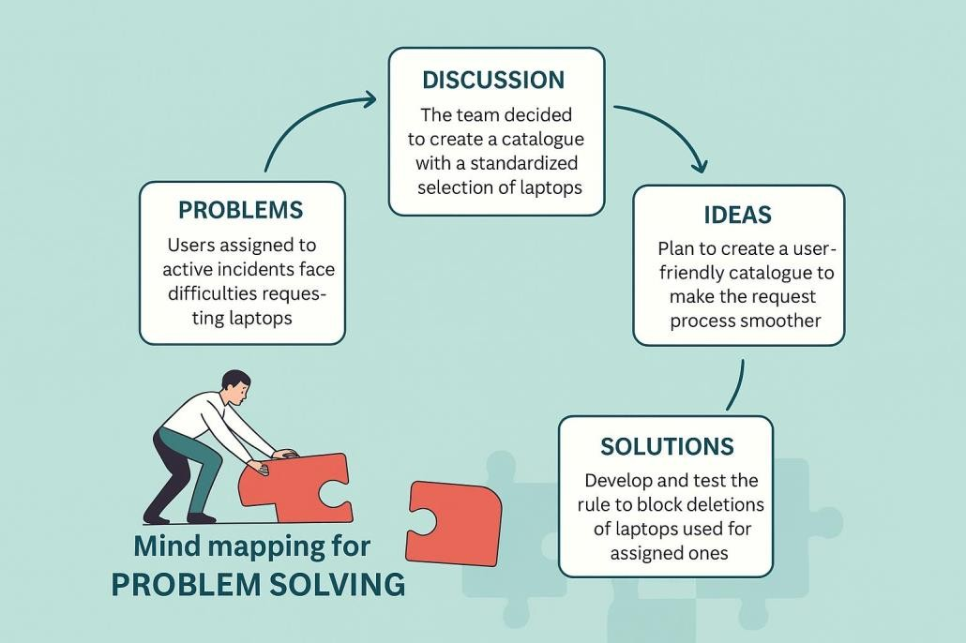

Currently, employees face delays and confusion while requesting laptops as there is no proper structured system. Manual requests through emails or messages make it difficult for IT teams to track and approve requests efficiently. There is no transparency on request status, leading to poor communication and resource mismanagement. This project aims to build a catalogue-based workflow that automates request submission, approval, and tracking.

Step 2: Brainstorm, Idea Listing and Grouping
Brainstorm: Team members discussed multiple approaches to enhance the request process. Focusing on automation, workflow approval, and stock management.

Idea Listing: Ideas include creating an online form, linking manager approval, integrating stock. Status, and sending email updates to users.

Grouping: Similar ideas were grouped into modules like Request Form, Approval System, Notification, and Inventory.

Action Planning: Final selected ideas were planned into implementation steps ensuring ease of Use and clarity.

Step 3: Idea Prioritization

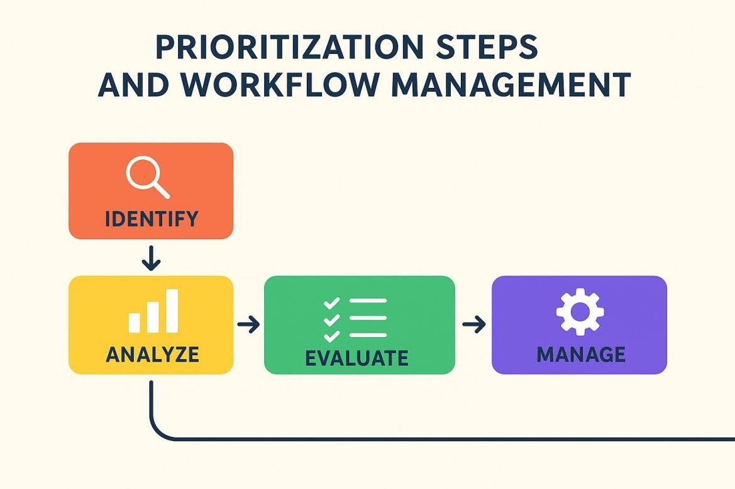

Idea Prioritization:
Idea prioritization helps convert brainstorming ideas into actionable steps. In this project, the key focus is to maintain an organized laptop request process. Prioritization includes defining catalog categories, automating approval steps, integrating admin dashboards, and ensuring secure inventory management. This process improves clarity, accountability, and workflow efficiency.

